# WHAT IS THE HTML

HTML stands for **H**yper**T**ext **M**arkup **L**anguage.

* A **markup language** defines the structure and presentation of raw text.
* A **HyperText** is text displayed on a computer or device that provides access to other text through links (hyperlinks).

**HTML** is a markup language used to create documents on the web. It describes the structure and layout of a web page.

# HTML HISTORY

**HTML** was originally developed by Tim Berners-Lee while at CERN.

HTML is a very evolving markup language and has gone through several changes since its inception. first version (HTML) was released in 1991 and the last one (HTML5)was released in 2014.

# HTML PAGE STRUCTURE

* The <head> element contains **metadata** about the page.

HTML metadata is data about the HTML document and metadata **is not displayed.** Metadata typically defines the document title, character set, styles, scripts, and other meta information.

* The <body> element indicates what **should appear in the main browser window**.

# A SIMPLE HTML DOCUMENT

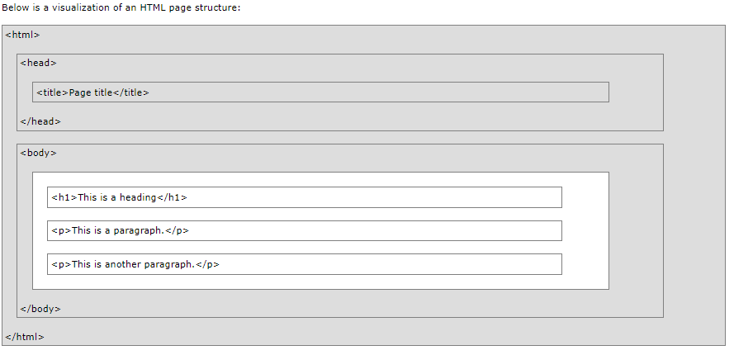

# EXPLANATION of HTML DOCUMENT:

* The <!DOCTYPE html> declaration defines this document to be HTML5.
* The <html> element is the root element of an HTML page.
* The <head> element contains meta information about the document.
* The <title> element specifies a title for the document.
* The <body> element contains the visible page content.
* The <h1> element defines a large heading.
* The <p> element defines a paragraph.

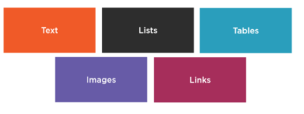

# HTML ELEMENTS

* HTML is composed of elements. HTML uses these elements to describe the structure of pages.
* A tag and the content between it is called an **HTML element**.
* Elements are usually made up of two tags: An **opening tag** and a **closing tag**.
* The opening tag is also called the starting tag, and the closing tag is called the end tag.
* Each HTML element tells the browser something about the information that is between its opening and closing tags.

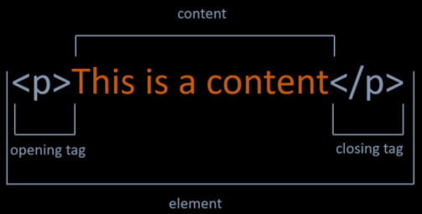

# NESTED HTML ELEMENTS

HTML documents consist of nested HTML elements. HTML elements can contain elements (elements can be nested). All HTML documents composed of nested HTML elements.

### EMPTY HTML ELEMENTS

* If a HTML element **does not have any content**, it is called empty element.
* Empty HTML elements **do not have a closing tag.**
* For example, <br> and <img> elements are empty elements.
* You will learn more about elements in this course.

### HTML TAGS

* **HTML tags** are element names surrounded by angle brackets. The element name indicates **the tag's purpose**. For example, p stands for paragraph.
* The opening tag denotes the start of a piece of content. The opening tag is composed of **the left-angle bracket, element name, and right-angle bracket.**
* The closing tag denotes the end of an HTML element. The closing tag is composed of the **left-angle bracket, forward slash, element name, and right-angle bracket.**

|  |  |
| --- | --- |
|  |  |

# HTML Div Tag

A <div> section in a document that is styled with CSS:

The <div> tag defines a division or a section in an HTML document. The <div> tag is used as a container for HTML elements - which is then styled with CSS or manipulated with JavaScript. The <div> tag is easily styled by using the class or id attribute. Any sort of content can be put inside the <div> tag!

Note: By default, browsers always place a line break before and after the <div> element.

# HTML ATTRIBUTES

* Attributes provide additional information about the contents of an element.
* **Attributes are always specified in the opening tag** and are **made up of two parts**: a name and a value, separated by an equals sign. For example, The style attribute is used to specify the styling of an element, like color, font, size etc.

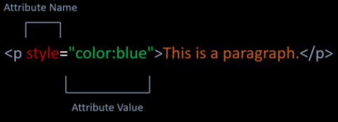

# HTML HEADINGS

* Headings are used to describe content, like the title of an article.
* HTML has six "levels" of headings, which are graded according to importance.
* Headings are defined with the <h1> to <h6> tags. <h1> defines the most important heading. <h6> defines the least important heading.

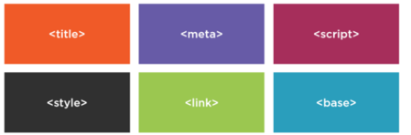

# HTML PARAGRAPHS

* The HTML <p> element stands for paragraph.
* Paragraph element **contains blocks of text.**

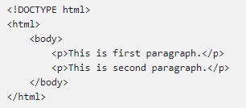

# HORİZONTAL LINES

* The <hr> tag creates a horizontal line.
* The <hr> tag is displayed as a horizontal rule.
* The <hr> tag **is used to separate content on a HTML page**.

|  |  |
| --- | --- |
|  |  |

# HTML LINE BREAKS

* The HTML <br> tag stands for a line break.
* The <br> tag **is used to add a single line break**.
* The <br> tag **has no end tag**.

|  |  |
| --- | --- |
|  |  |

# HTML COMMENTS

* Comments can add the text between these characters.

<!-- This is a comment-->

* The browser does not display comments, but with comments, we can place warnings, descriptions and other notes.
* Comments are also imported for debugging HTML. We can use comments for searching errors.

# HTML ELEMENTLER

# HTML < b > Element

* The <b> element is used to define bold text.

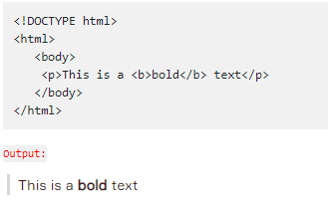

# HTML < strong > Element

* The <strong> element is used to define strong text.
* The <strong> element uses for the semantic important texts.

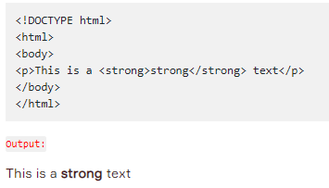

# HTML < i > Element

* The <i> element is used to define italic text.

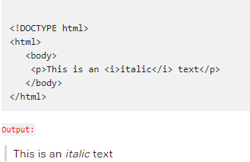

# HTML < em > Element

* The <em> element is used to define emphasized text.
* <em> means that the text is "important".

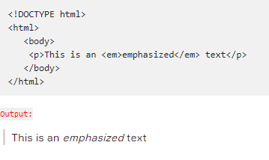

# The Difference Between Bold and Strong, Emphasized and Italics.

* <strong> and <b> tags make text bold. They're identical when it comes to presentation.
* <strong> represents a span of text with strong importance. There is an important semantic meaning here. They may look the same to humans. But, when a search engine spiders and analyzes a page, text in <strong> tags is considered important. Text in <b> tags is not.
* Just like <strong> and <b>, <em> and <i> are identical in terms of presentation. They both make text italic. There is no semantic meaning for <i> tag. But, <em> tag represents a span of text with emphatic stress like <strong> tag.

# HTML < small> Element

* The <small> element is used to define smaller text.

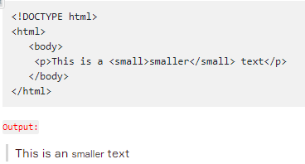

# HTML < sup > Element

* The <sup> element is used to define superscript characters such as the suffixes of dates.

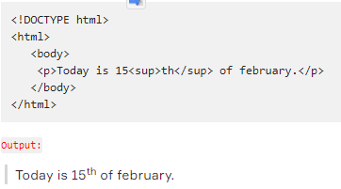

# HTML < sub > Element

* The <sub> element is used to define subscripted text.

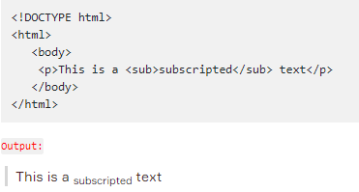

# HTML < mark > Element

* The <mark> element is used to define marked text.

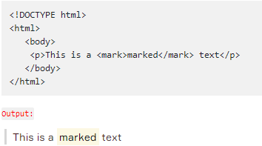

# HTML < ins > Element

* The <ins> element is used to define inserted text.

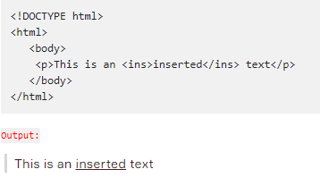

# HTML < del > Element

* The <del> element is used to define deleted text.

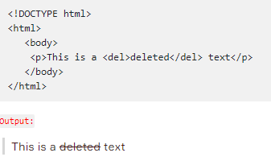

# Summary of HTML Formatting Elements

|  |  |
| --- | --- |
|  |  |
|  | |

# HTML Formatting Elements

# Ordered List Elements

* The <ol> element is used to create ordered lists with a sequential order.
* Each list item is defined by the <li> tag.

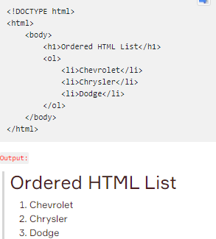

# Unordered List Elements

* The <ul>element is used to create unordered lists with no particular order.

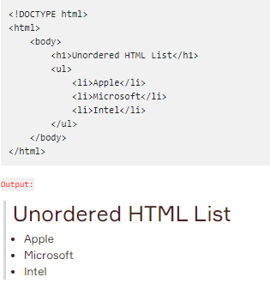

# HTML Tables

# Basics of Table

* In order to create a table in HTML, we use <table> tag.
* The <tr> tag is used to define each table row.
* The <th> tag defines a table header.
* A table cell is defined with the <td> tag.
* Here is an example of a simple table with four rows and two columns.

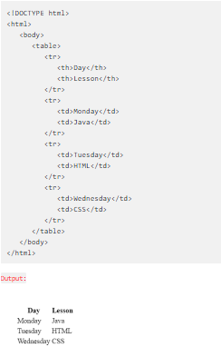

# Table Border

* We can add border to table with **border** attribute in table tag like example below.
* The border attribute is not supported in HTML5. Use CSS instead.

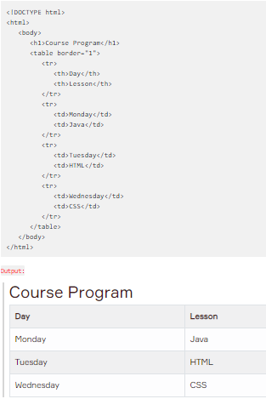

# Colspan Attribute

* We can span two or more columns by using the colspan attribute like example below.  
    
  < td colspan="2" >Java< /td

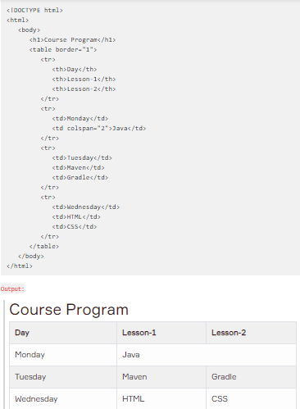

# Rowspan Attribute

* We can span two or more rows by using the rowspan attribute like example below.  
  < td rowspan="2" >Java< /td >

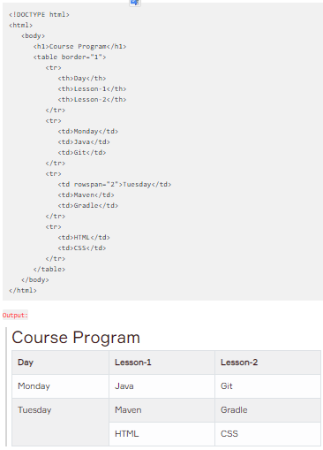

# Align Attribute

* To change table or cell position, we can use the align attribute inside <table> tag or <td> tag.  
    
  <td align="center">java</td >

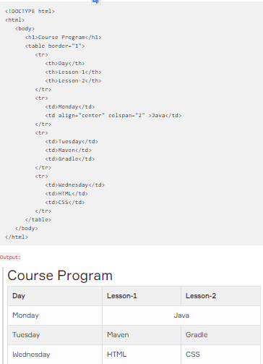

# HTML Images

# The < img > Tag

* We can improve the design of a web page by adding images.
* The <img> tag is used to define an image.
* The <img> tag is empty. It means that it does not have a closing tag.
* The **src** attribute allows us to specify the web address (URL) of the image and it is mandatory.

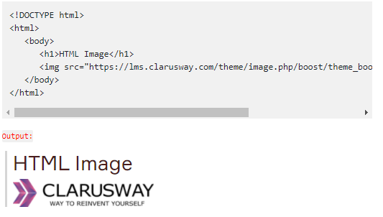

# The alt attribute

* The **alt** attribute is used to provide an alternate text for an image in case the image fails to load on a web page or it is not supported by the browser, etc.
* Moreover, Visually impaired users browse the web via screen reading software. the screen reading software can read the text inside an alt attribute for impaired users.
* We should add alt attribute to the image tag just like the src attribute.

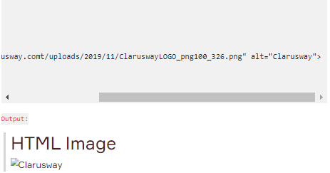

# The width and height attributes

* The width and height attributes are used to resize images.

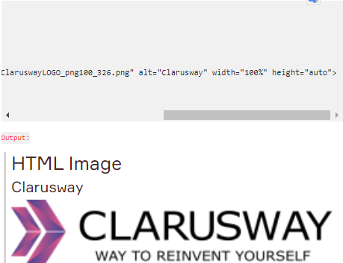

# The border attribute

* By default, an image has no borders.
* To add a border around the image, we can use border attribute.

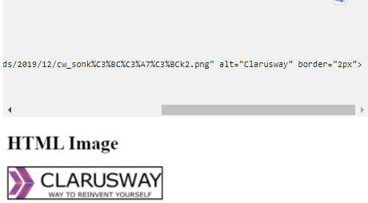

# HTML Links

# The < a > Tag

* One of the advantages of HTML , is the ability to link to other web pages.
* The <a> element and including text is used to define a link.

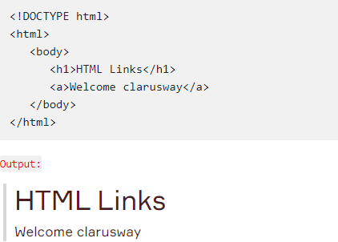

# The href Attribute

* Technically, we didn't complete the HTML link.
* We need href attribute inside opening <a> tag to specify which page we want to link.
* The **href** attribute defines the address of the link.

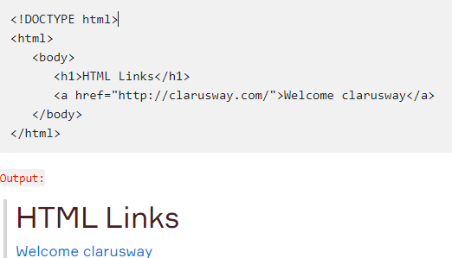

# The target Attribute

* The target attribute is used to specify how a link should open.
* In order to open link in a new page, the target attribute requires a value of _blank.
* We should add the target attribute inside opening <a> tag like href attribute.

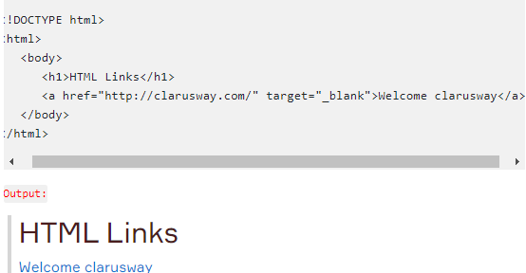

# Image as a Link

* We can use an image as a link in HTML.
* For this, it is enough to put an <img> tag between opening and closing <a> tag.

